**Summary of the previous meeting(s)**

Keith’s email:

[https://s-media-cache-ec0.pinimg.com/originals/e5/e4/99/e5e499ab7ca3c762b097b8837ffc8dd0.jpg](https://s-media-cache-ec0.pinimg.com/originals/e5/e4/99/e5e499ab7ca3c762b097b8837ffc8dd0.jpg" \t "_blank)

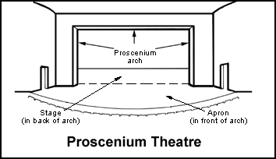

**This week**

Task: Anamorphosis on flat surfaces

Write a program to pre-warp an image (generate anamorphosis) so that the camera (acting as the viewer) can see the correct image.

Surface type: plane

Equipment used: Pico projector, camera, laptop

Assumptions: the entire system is fixed after calibration

1. Calibrate:
   1. Project 4 bright dots
   2. Camera: detect dots
   3. Generate homography H relating camera image and projector image
2. Using the homography matrices, warp the image to create anamorphosis
3. Projector: display the resulting image